**Custom Component Creation Guide**



**Building a Component**

**Working with Custom Components**

**What is a Custom Component?**

The Custom Component allows creating custom-tailored components. Each custom component can connect to several other components, and you can see in the blue/red circles the components that can connect to it.

Using Custom Component, you can create a custom component that will fit exactly the Workflow you are building.

תמונה שמכילה טקסט, צילום מסך, מספר, תוכנה

תוכן בינה מלאכותית גנרטיבית עשוי להיות שגוי.

This component, like every component, has connections that represent inputs and outputs of different data types. Each circle color has a meaning for connection.

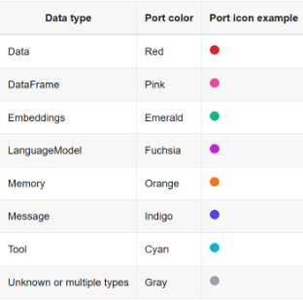

**Where to find the Custom Component:**

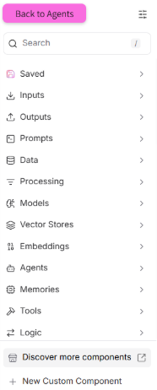

**How do we adapt the component to our needs?**

Click on the component with the Code button to open a code box where you can edit its internal code. In the code, we'll insert the desired code that tells the component what it should do (you can use chat to help write the desired code). Immediately after inserting the desired code, the component's name, logo, and purpose will change. You can add additional connections using curly brackets { }, every time we write curly brackets we open an additional connection to a TOOL or component or data connection that will connect to the component.

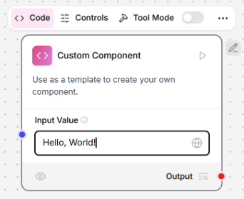

**How to create code for a custom component:**

You need to copy the suggested prompt here, add the missing details to it, attach the basic code, and send to chat.

**Template for prompt to create a custom component -**

**Prompt:** I have basic code for a component, update the code so that the component will do - (Goal: [exact goal description].) Update the code so that the component implements the goal. Keep the structure of Component, inputs, outputs, Data) and update names/fields/logic as needed.

**Basic Code:**

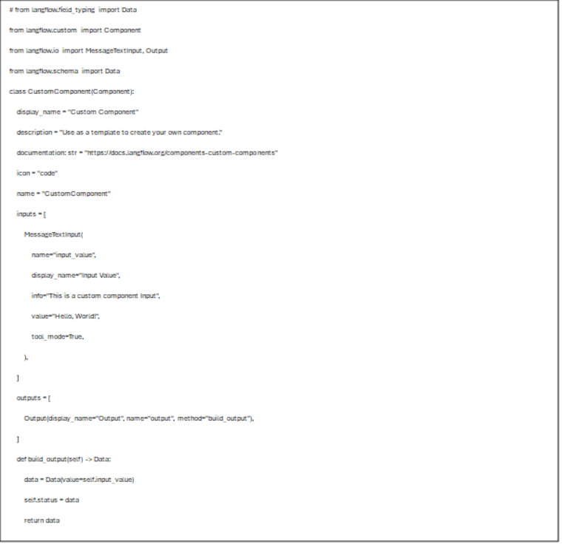

You can make changes like saving the component, changing the name, duplicating, or copying data by clicking on the three dots.

